PRR &VS GOVT,COLLEGE.
VIDAVALURU,SPSR NELORE Dist.,
DEPARTMENT OF TELUGU

FIELD TRIP
----------------------------------------------------------------------------------------------------------------------------------------
Department of Telugu went to Educational tour along with college on 14 June 2022. All college students visited SHAR and Chengalamma Temple. In SHAR before visit the rocket launch pad, they know the importance of books and see the various types of scientific books, where they visited library and watch the show about origin of SHAR and expansion of activities. After that they visited MUSIUM. In return students visited Chengalamma Temple in Sullurpet, SPSR Nellore Dist., They observed History of temple and Historical importance.
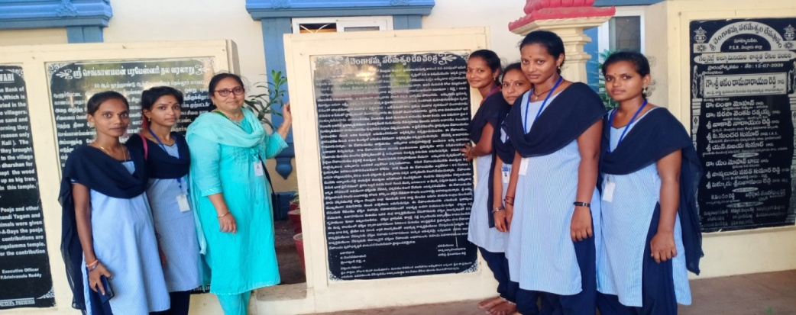

చెంగాళమ్మ స్థల పురాణం తెలిపే శాసనం
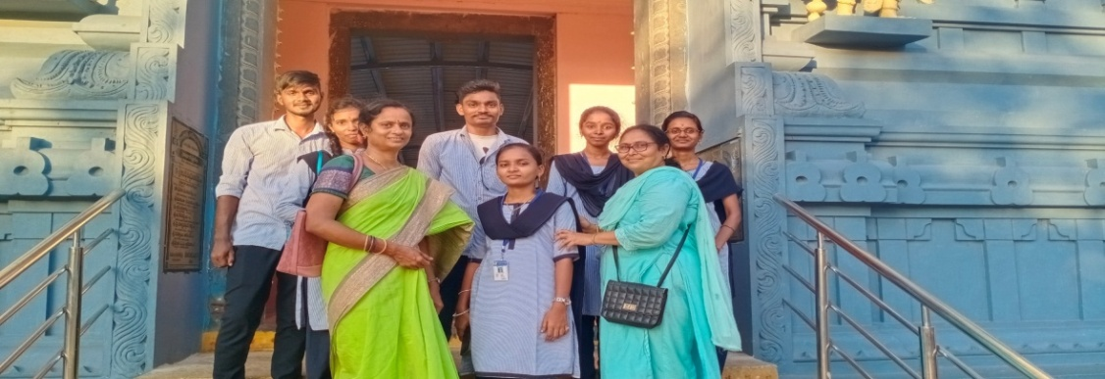

చెంగాళమ్మ గుడి
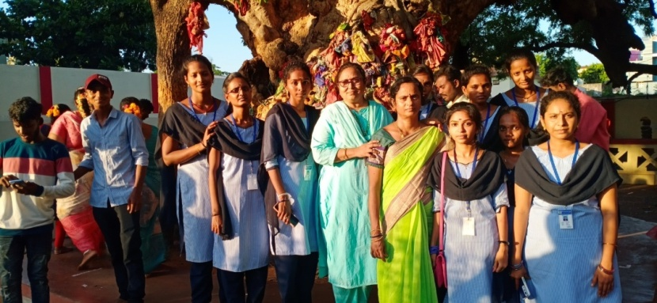
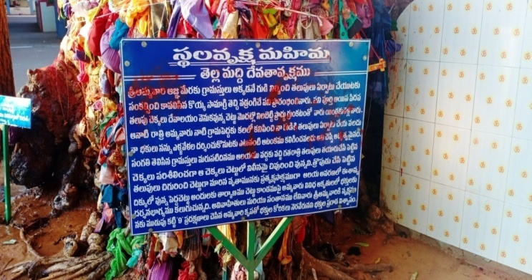
veవే

చెంగాళమ్మ వేపవృక్ష ప్రాధాన్యత వివరణ

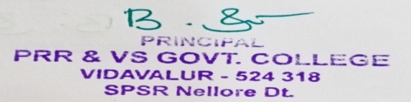
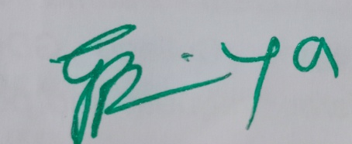

Signature of the Lecturer Signature of the Principal

